File name analysis
 | ＤＰＣ電子点数表の前提条件 | Prerequisites for the DPC electronic point table
 | ダミーコード一覧 | List of dummy codes
 | １）ＭＤＣ名称 | 1) MDC name
 | ２）分類名称 | 2) Classification name
 | ３）病態等分類 | 3) Pathological classification
 | ４）ＩＣＤ  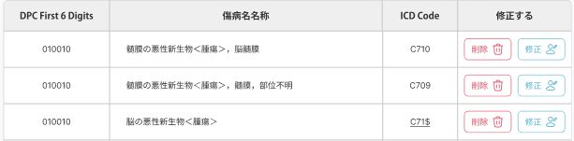 | 4) ICD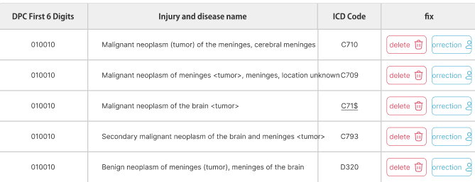 | DPC M >> L1 Layer  ICD-DPC
   | ICD名称 | ICDｺｰﾄﾞ
    MDCｺｰﾄﾞ | 分類ｺｰﾄﾞ
  MDC Code Classification Code | ICD Name
    ICD code
 | ５）年齢、出生時体重等  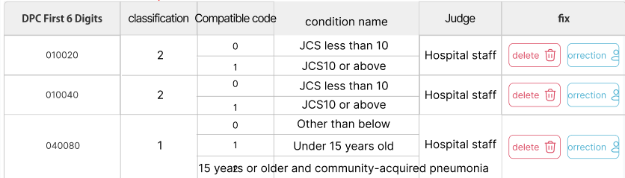 | 5) Age, birth weight, etc.  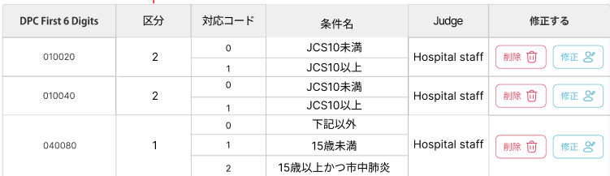 | DPC M >> L1 Layer  Age
   | 条件区分 | 値 | 条件名
    MDCｺｰﾄﾞ
    分類ｺｰﾄﾞ
    Daichan comment
   |  | value | Condition Name | Daichan's comment
    Condition Class
 | ６）手術  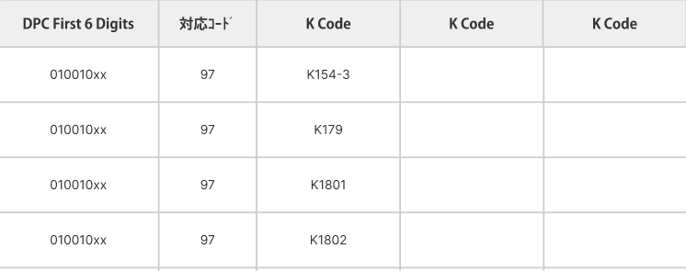 | 6) Surgery  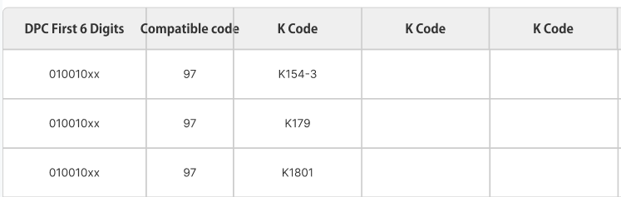 | L2 Surgery
  MDCｺｰﾄﾞ +分類ｺｰﾄ | 対応ｺｰﾄﾞ | Ｋコード
   | Corresponding code | K Code
 | ７）手術・処置等１  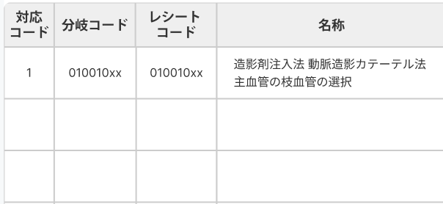 | 7) Surgery, treatment, etc. 1  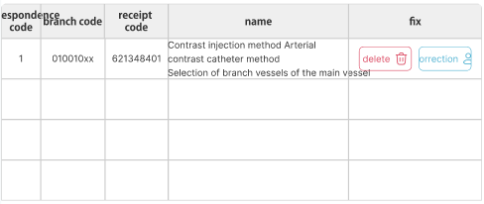 | L3 >> treatment 1
  対応ｺｰﾄﾞ |  | C | 名称
  Corresponding code |  | C | name
 | ８）手術・処置等２  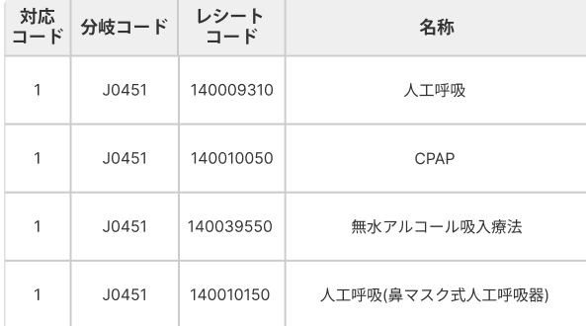 | 8) Surgery, treatment, etc. 2  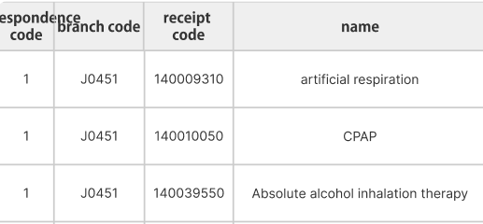 | L3 >> treatment 2
  対応ｺｰﾄﾞ |  |  | 名称
  Corresponding code |  |  | name
    Daichan made it
 | ９）定義副傷病名  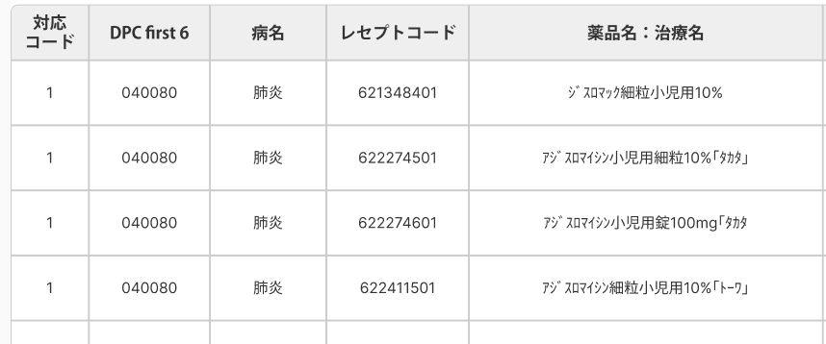 | 9) Defined secondary injury/illness name  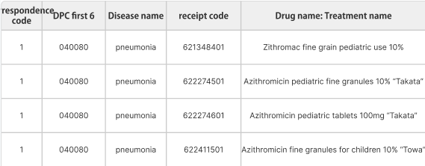 | L3 >> secondary
  対応ｺｰﾄﾞ | MDCｺｰﾄﾞ +分類ｺｰﾄﾞ |  |  | ICD名称
  Corresponding code |  | Diease name | auto | ICD Name
    MDC Code | Classification Code
 | 10－1）重症度等（ＪＣＳ等） | 10-1) Severity, etc. (JCS, etc.) | L3 >> Score
 | 10－2）重症度等（手術等） | 10-2) Severity, etc. (surgery, etc.) | L3 >> Score
 | 10－3）重症度等（重症・軽症） | 10-3) Severity, etc. (severe/mild) | L3 >> Score
 | 10－4）重症度等（脳卒中の発症時期等） | 10-4) Severity, etc. (time of onset of stroke, etc.) | L3 >> Score
 | 11）診断群分類点数表 | 11) Diagnosis group classification point table
 | 12）変換テーブル | 12) Conversion table
 | 13)出来高算定手術等コード | 13) Fee-for-service-based surgery code
 | 14）CCPM対応 | 14) CCPM compatible

Patient Data
Medicine =start 6 & 9 digit
Medical Practice =start 1 & 9 digit
Injuries = less than 9 digit
# receive code none any 3 tables but icd to dpc found.
# receive code present any 3 tables then does icd to dpc found.? Yes
# icd code $ = variables contains in patient excel
# K code inside icd -> dpc & also found on surgery code .
# Age 0= [<10] || 1 from dob
# Sergery 01-06 / 99/ 97
# Treatment 1 . 0/1/2-5 [Treatment 2 . 0/1/2-9/A-C] [Secondary injury 0/1/2]

 | Patient Code | Doctor (accountant) | Master code for computerized receipt | Accounting Date | Insurance Type | Treatment No. Name | Calculation items | Points and amount | Date of admission (DPC admission information) | Discharge date (DPC hospitalization information) | Department (DPC admission information) | ward | ICD codes for injuries and illnesses requiring the most medical resources | date of birth | Disease name |  | 患者コード
500925

